Empathize and Discover
Incident Lifecycle Automation in ServiceNow

1. Purpose
The empathize and discover stage explores the experiences, needs, and difficulties of people involved in incident management. The aim is to understand the problem before deciding which ServiceNow features or workflow changes should be used.

2. Stakeholder perspectives
End users: need a simple way to report issues, provide useful details, and understand the current status.
- Service desk agents: need complete incident information, clear priorities, visibility of ownership, and an efficient way to route work.
Technical support teams: need relevant diagnostic details, access to previous solutions, and clear handover information.
Administrators and process owners: need configuration that is maintainable, follows access controls, and supports consistent reporting.

3. Discovery questions
- How are incidents currently reported and recorded?
- What information is often missing when an incident is first created?
- How are category, impact, urgency, and priority determined?
How is the correct assignment group selected?
- Where do delays or repeated manual actions occur?
How do users and support teams learn about status changes?
- Are Knowledge articles available and easy to locate?
- When does an incident require a related change record?
- What information is required before an incident can be resolved and closed?

4. Empathy map template
- Think and feel: What concerns does the user have while waiting for an issue to be resolved?
- See: What status, fields, messages, or queues does the user or agent see?
- Say and do: What actions do users and agents take to report, update, investigate, or resolve an incident?
- Hear: What updates or instructions do they receive from colleagues or the service desk?
- Pains: What causes confusion, repeated work, missing information, or delays?
- Gains: What would make reporting, tracking, and resolving incidents easier?

5. Initial pain points to validate
Incident details may be incomplete at submission.
Priority and categorisation may be applied inconsistently.
Manual routing or follow-up may delay ownership and progress.
Users may lack clear visibility into incident status.
Previously documented solutions may not be reused consistently.
Resolution notes may vary in quality, limiting future troubleshooting.

6. User needs and opportunity statements
Users need a clear reporting and status-tracking experience so they know what is happening with their issue.
Support agents need consistent incident information and prioritisation so they can assess and route work appropriately.
Technical teams need accessible knowledge and useful resolution notes so they can investigate issues efficiently.
Process owners need traceable lifecycle states and reliable records so they can review process performance.

7. Suggested discovery methods
Stakeholder interviews or short questionnaires.
Walkthrough of the current incident process in a development or training instance, where authorised.
Review of sample or anonymised incident records, if access is permitted.
Process mapping from incident creation to closure.
Validation meeting to confirm pain points and rank user needs.

8. Findings and validation log
Observation / pain point:
Who experiences it:
Evidence or example (avoid sensitive information):
How often it occurs:
Potential opportunity:

9. Discover-stage conclusion
The discovery stage should produce a validated summary of user needs, key pain points, and opportunities for improvement. The initial points in this document are hypotheses for discussion and must be confirmed with stakeholders or process evidence before being treated as actual findings.

Process Diagram
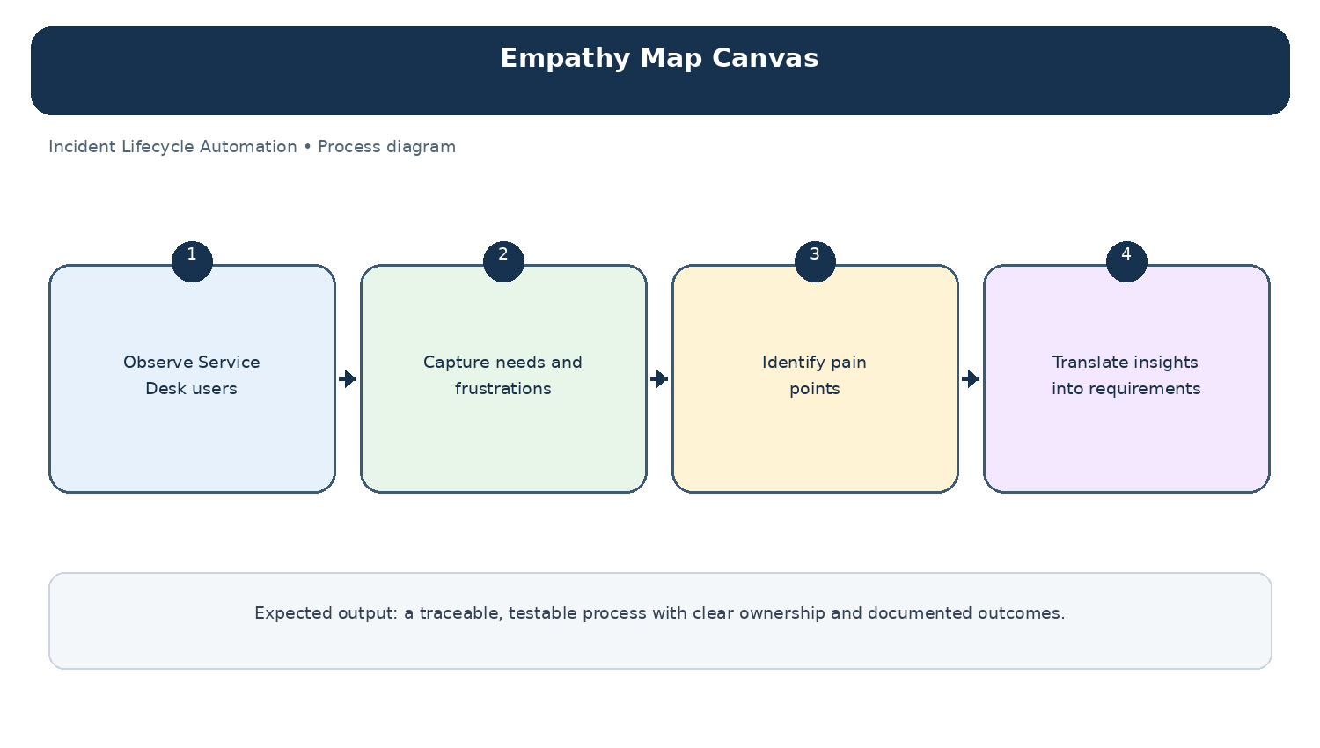
Diagram: Empathy Map Canvas — project-specific process overview.

